## **Building a Swarm**

I'll do a really quick demo on how to build a Docker swarm with 3 managers and 3 workers.

For that I'm going to deploy 6 droplets on DigitalOcean:

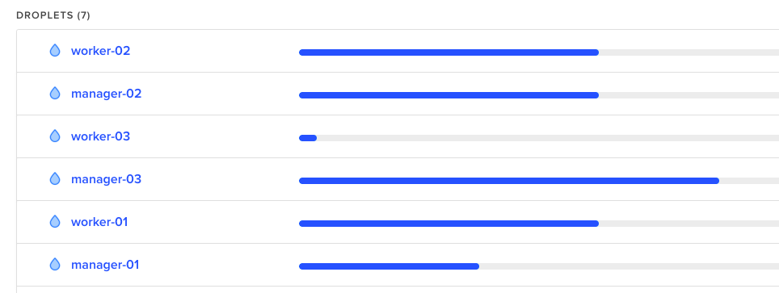

Then once you've got that ready, install docker just as we did in the [Introduction to Docker Part 1](https://devdojo.com/tutorials/introduction-to-docker-part-1) and then just follow the steps here:

### **Step 1**

Initialize the docker swarm on your first manager node:

docker swarm init --advertise-addr your_dorplet_ip_here

### **Step 2**

Then to get the command that you need to join the rest of the managers simply run this:

docker swarm join-token manager

Note: This would provide you with the exact command that you need to run on the rest of the swarm manager nodes. Example:

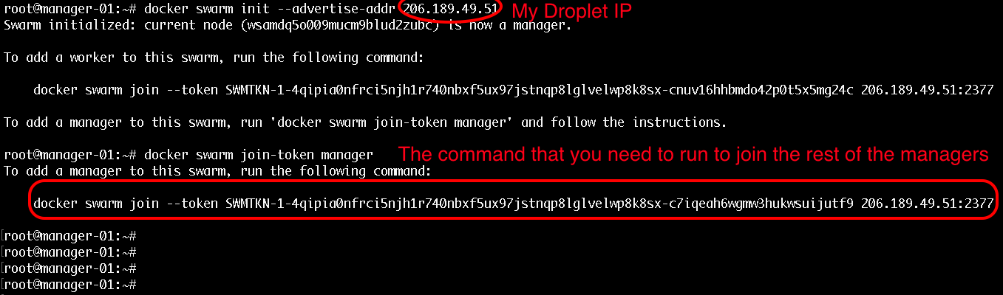

### **Step 3**

To get the command that you need for joining workers just run:

docker swarm join-token worker

The command for workers would be pretty similar to the command for join managers but the token would be a bit different.

The output that you would get when joining a manager would look like this:

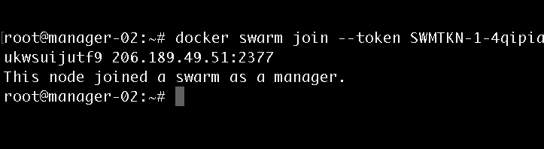

### **Step 4**

Then once you have your join commands, ssh to the rest of your nodes and join them as workers and managers accordingly.

# **Managing the cluster**

After you've run the join commands on all of your workers and managers, in order to get some information for your cluster status you could use these commands:

* To list all of the available nodes run:

docker node ls

Note: This command can only be run from a swarm manager!Output:

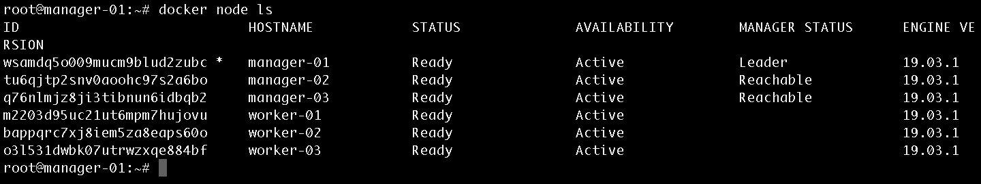

* To get information for the current state run:

docker info

Output:

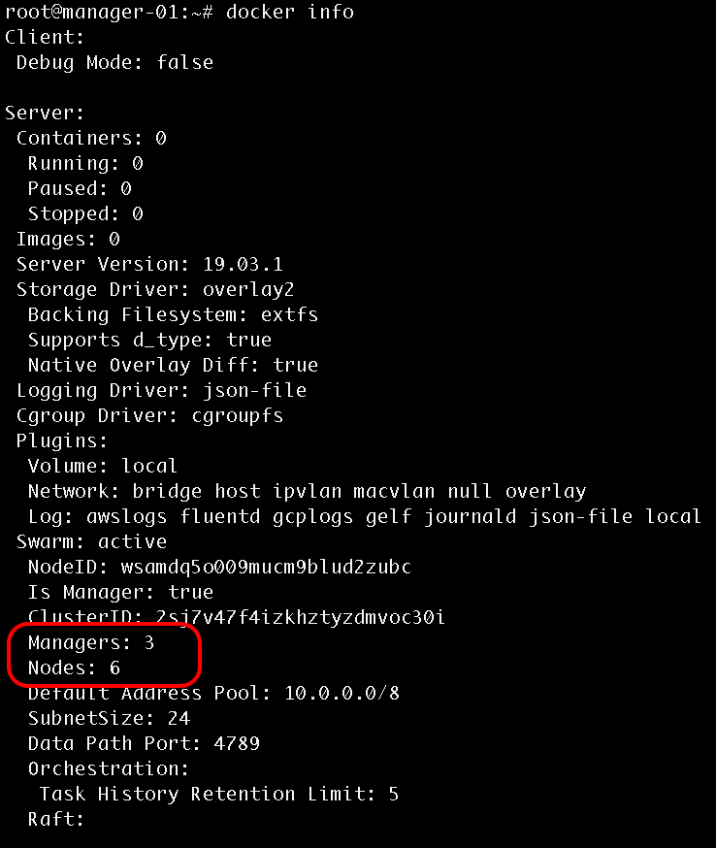

## **Promote a worker to manager**

To promote a worker to a manager run the following from one of your manager nodes:

docker node promote node_id_here

Also note that each manager also acts as a worker, so from your docker info output you should see 6 workers and 3 manager nodes.